**Performance Analysis of Python AES module using 2k factorial design**

**Project By:**

Shuvo Saha Roy- SAU/CS(M)/2020/22

Mahen Mondol-SAU/CS(M)/2020/09



Submitted To:

[**Shachi Sharma**](http://www.sau.int/faculty/faculty-profile.html?staff_id=87)

Assistant Professor

South Asian University, New Delhi

**Submission Date:**

12-07-2021

**Abstract**

Nowadays, information security has become an essential issue for exchanging information in data communication. Encryption algorithm plays a vital role in the information security system. Many algorithm techniques are used to provide data confidentiality and privacy by making the information indecipherable which can be only be decoded or decrypted by the party that possesses the associated key. However, concurrently implementing these algorithm techniques consume a significant amount of computing resources such as CPU time, memory, and battery power. [1] So it is crucial to find out the effect of the algorithm upon these resources. It will help us to determine significant factors that were affecting the performance of the algorithm. This project provides an evaluation of the Python AES module from pycrypto[2] package, cryptographic algorithms by taking different types of files like mp3, text, image, py scripts, pdf, and video files. A comparison has been conducted among various resources using evaluation parameters such as encryption time, decryption time, and memory throughput. Simulation results are given to demonstrate the effectiveness of each.

**Keywords:** **Algorithm, Encryption, Decryption, AES, Python**

**Introduction**

Data is the most important thing in this era. The amount of data is increasing day by day with the use of the internet. So it needs to ensure the safety of data as efficiently as possible. Different encryption technique is used to ensure the safety of data or secure the data. Now Advanced Encryption Standard AES encryption is the most popular encryption technique that is used all over the world. [3]In this project, pycrypto, a python package used to analyze the performance of the AES 256bit module. The implementation code is available here ([GitHub](https://github.com/ssroy548/Performance-Modeling-/blob/master/script.py)). 2^k factorial design is used for the performance analysis. 2^k factorial design is used to find out if a variable is significant to affect a process or not. If k number of variables/factors are studied to determine/screen the important ones, the total number of treatment combinations for a k number of factors can be calculated. Therefore, this screening technique is known as the 2K design of experiments. [4] Python programming language used to monitor the resource uses for the AES encryption algorithm. AES (Advanced Encryption Standard) is a symmetric block cipher standardized by NIST. It has a fixed data block size of 16 bytes. Its keys can be 128, 192, or 256 bits long. AES is speedy and secure, and it is the standard for symmetric encryption.

**Methodology**

Python programming language with the 2^k factorial design is used to identify the significant factors for AES algorithm implementation.

**Encryption and Decryption (AES):** Encryption is a process that transforms the original information into an unrecognizable form. This new form of the message is entirely different from the original message. That's why a hacker is not able to read the data as senders use an encryption algorithm. Encryption is usually done using key algorithms. The Advanced Encryption Standard (AES) is a Federal Information Processing Standard (FIPS) which was declared after the competition for encryption algorithms held by National Standards and Technology in 2011. AES is a very high-security algorithm [1]. Some algorithms were selected as candidates in the top 5 in a row after Rijndael are Serpent, Twofish, RC6, and MARS algorithms [5]. AES is proven immune to conventional attacks (linear and differential are: resistant to known password analysis, flexible to use in various hardware and software, good for hash functions, suitable for devices that require fast key agility, and ideal for stream ciphers. Decryption is converting encoded/encrypted data in a form that is readable and understood by a human or a computer. This method is performed by un-encrypting the text manually or using keys to encrypt the original data.

**Python**

Python is an interpreted, object-oriented, high-level programming language with dynamic semantics. It's high-level built-in data structures, combined with dynamic typing and dynamic binding, make it very attractive for Rapid Application Development. The Python interpreter and the extensive standard library are available in source or binary form without charge for all major platforms and can be freely distributed.

**Advantage of python**

* Presence of third-party modules
* Extensive support libraries
* Open source and community development
* Versatile, Easy to read, learn and write
* User-friendly data structures
* High-level language
* Portable and Interactive
* Ideal for prototypes – provide more functionality with less coding

**PyCrypto**

Python crypto module provides a simple interface to symmetric Gnu Privacy Guard(gpg) encryption and decryption for one or more files on UNIX and Linux platforms. It runs on top of gpg and requires a gpg install on your system. Encryption is performed with the AES256 cipher algorithm. Benchmarks relative to default gpg settings are available for text and binary file mime types.

**Data Selection**

To collect the data, two steps are taken into consideration.

1. Installing essential programs and modules.

The first step is to install python into the machine. To run AES encryption and decryption, Crypto module is needed, and it has installed using the following command:

pip install crypto

Another module used to compute the system information, which is psutil, available by default.

1. Writing script to compute the effect of total CPU utilization, central memory (ram utilization, the execution time of the AES encryption algorithm.

**Factor identification**

To apply 2^k factorial design, it's essential to identify factors, parameters. CPU utilization, ram utilization , ram usage, execution time, total ram, cpu usage of whole system, disk usage, etc are shown in the data set. Among them, some of the system information, which has no relation with the program. Also, CPU utilization is 0 percent for the program. That's mean this program is not CPU sensitive. So if we look deeper, among different parameters, there are three factors considered for the AES algorithm's performance analysis.

* **Size of folder**
* **Size of RAM**
* **Operation type (Encryption, Decryption)**

As encryption and decryption are performed at bytes level, so the format of the file does not matter and has no impact as a factor. On the other hand, for simplifying calculation, size folders are considered rather than each file size.

|  |  |  |  |  |  |  |  |  |  |
| --- | --- | --- | --- | --- | --- | --- | --- | --- | --- |
| cpu_utlilization % | memory_utilization % | memory_usage MB | directory size MB | time_taken sec | operation_type | total cpu in use % | total ram GB | ram in use % | disk_usage % |
| 0 | 0.198752403 | 16.0234375 | 22.83258343 | 0.338886261 | encription | 19.1 | 7.867298126 | 40.3 | 65.9 |
| 0 | 0.198655427 | 16.015625 | 732.4565725 | 14.90413904 | encription | 28 | 7.867298126 | 38 | 68.1 |
| 0 | 0.400014879 | 16.38671875 | 27.05152798 | 0.571216106 | encription | 7.5 | 3.99956131 | 40.1 | 61.2 |
| 0 | 0.391526247 | 16.04296875 | 175.2835598 | 5.858032465 | encription | 29.5 | 3.99956131 | 39.8 | 61.2 |
| 0 | 0.199867628 | 16.11328125 | 22.83254623 | 0.200044632 | decryption | 39.2 | 7.867298126 | 38.1 | 65.7 |
| 0 | 0.199188795 | 16.05859375 | 732.4565115 | 9.689086676 | decryption | 29.2 | 7.867298126 | 38.5 | 68.1 |
| 0 | 0.39047709 | 16 | 27.05177689 | 0.651234627 | decryption | 13.4 | 3.99956131 | 39.8 | 61.2 |
| 0 | 0.391621624 | 16.046875 | 175.2836447 | 3.669473648 | decryption | 33.2 | 3.99956131 | 39.8 | 61.2 |

**Table 1: Output and Selected dataset for 2^k factorial design ([GitHub](https://github.com/ssroy548/Performance-Modeling-/blob/master/test%20dataset.xlsx)). Some properties belong to the total system. So these are ignored during 2^k factorial design**

**Designing Workload**

For the analysis, the existing system was used as a real workload. Several requests have been made by running the script.py file. We categorized different folders with different sizes to run the experiment. There are two types of operation encryption and decryption, two different size of folders, and two systems with two different RAM sizes (8GB and 4GB).

|  |  |  |  |  |
| --- | --- | --- | --- | --- |
| **Folder Size** | **Encryption** |  | **Decryption** |  |
|  | 4GB RAM | 8GB RAM | 4GB RAM | 8GB Ram |
| Size<100 | Selected matrix | Selected matrix | Selected matrix | Selected matrix |
| Size>100 | Selected matrix | Selected matrix | Selected matrix | Selected matrix |

**Table 2: Key idea for 2^k factorial design**

**Result & Discussion**

As 2^k factorial design with three factors, 2^3 = 8 experiments are conducted. Four encryption and four decryption are performed in two different systems. Three matrices are taken into consideration as output variables from the dataset in this project work. These are Execution time- Time taken to execute the program, Memory usage, Memory utilization.



**(a)**



**(b)**

**Table-3(a,b): Shows the factorial design for execution time**

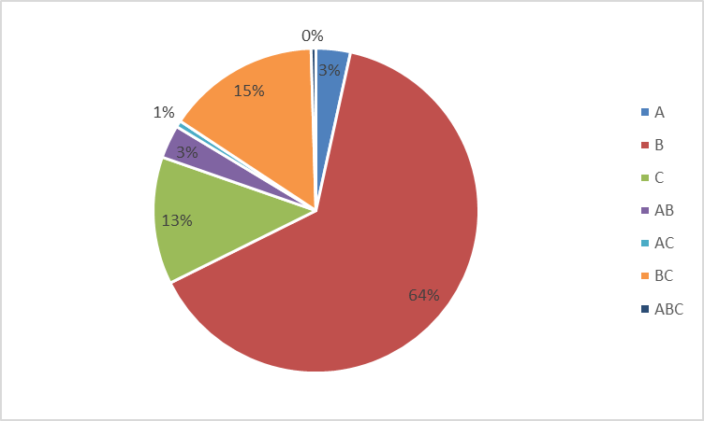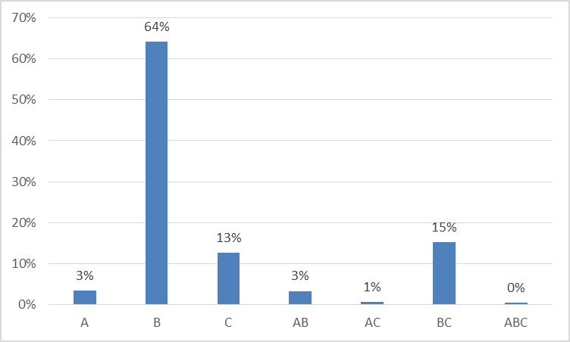

**(a) (b)**

**Figure 1(a,b): Graphical representation of 2^k factorial design for execution time**

Table 3 and figure 1([github](https://github.com/ssroy548/Performance-Modeling-/blob/master/execution%20timetime%20as%20matrix.xlsx)) show us B means folder size is the most important factor affecting the execution time for encryption and decryption. And BC together is the next significant factor, then C means RAM size is the most significant factor, and so on.



**(a)**



**(b)**

**Table 4(a,b): Shows the factorial design for RAM usage**

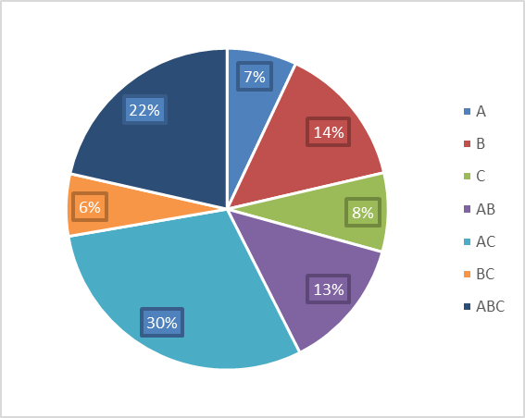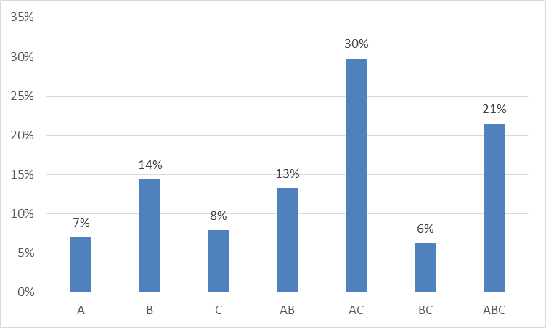

**(a) (b)**

**Figure 2(a,b): Graphical representation of 2^k factorial design for memory usage**

Table 4 and figure 2([github](https://github.com/ssroy548/Performance-Modeling-/blob/master/memory%20usage%20as%20matrix.xlsx)) shows us the analytical result 2^k factorial design for RAM usage. When RAM usage has used the combination of A(Operation type) and C(RAM size) shows the highest impact on performance.



**(a)**



**(b)**

**Table 4(a,b): Shows the factorial design for RAM usage**

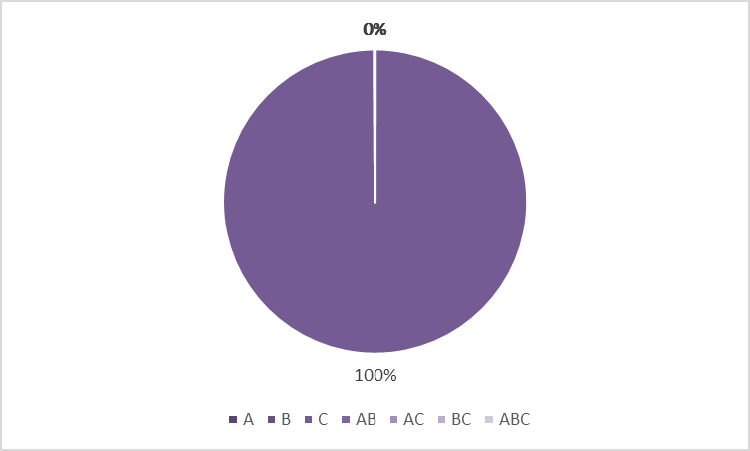

**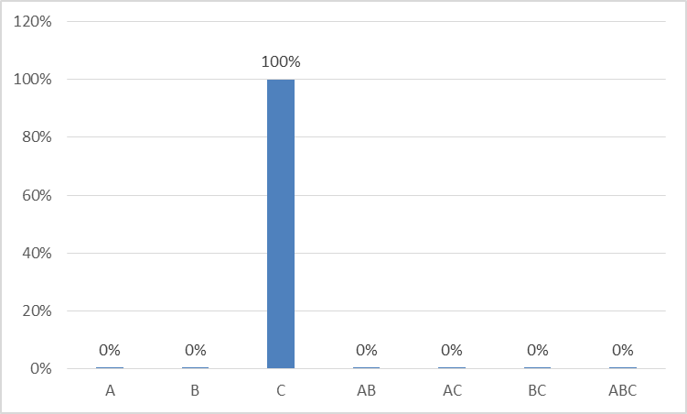  
(a) (b)**

**Figure 3(a,b): Graphical representation of 2^k factorial design for memory utilization**

Table 4 and figure 4 show ([github](https://github.com/ssroy548/Performance-Modeling-/blob/master/memory%20utilization%20as%20matrix.xlsx)) that when we take memory utilization as matric, it depends on RAM size. The size of the folder, operation type has no impact on the performance of the program. The program is totally RAM-sensitive.

**Conclusion & Future Work**

This project shows us that folder size and RAM is the most important factor, to measure the performance of the Python AES algorithm implementation. In 2nd analysis, it indicates that RAM usage depends on the operation type and RAM size mostly.

And in the 3rd analysis shows memory utilization totally depends on the memory size. So depending on these three results, we can say that the performance of the PyCrypto package AES (module) algorithm depends on folder size and ram mostly. And, this experiment shows us, it can be extended by using different systems or machines. Because here only 2 type system used. We can continue it for different ram size systems and different CPU configurations. Also, it can be done on other programming languages with appropriate packages. This will help us to understand the impact of algorithm implementation of different languages on different machines. After that, we can pick up the best one for our operational purpose.

**Reference**

1. M. Panda, "Performance analysis of encryption algorithms for security," 2016 International Conference on Signal Processing, Communication, Power and Embedded System (SCOPES), 2016, pp. 278-284, doi: 10.1109/SCOPES.2016.7955835.
2. pycrypto. PyPI. ((2021, June 30).). https://pypi.org/project/pycrypto/.
3. Kumar P dan Rana S B 2016 Development of modified AES algorithm for data security Opt. - Int. J. Light Electron Opt. **127** 2341–5
4. The Open Educator - 1. What is 2K Design. (n.d.). https://www.theopeneducator.com/doe/2K-Factorial-Design-of-Experiments/What-is-2K-Factorial-Design-of-Experiments.
5. Karale S N, Pendke K dan Dahiwale P 2015 The survey of various techniques & algorithms for SMS security *2015 International Conference on Innovations in Information, Embedded and Communication Systems (ICIIECS)* (IEEE) hal 1–6
6. *Python Language advantages and applications*. GeeksforGeeks. (2021, June 30). https://www.geeksforgeeks.org/python-language-advantages-applications/.